Registration Instructions
WIHA Training Center
- Find a course you’re interested in.
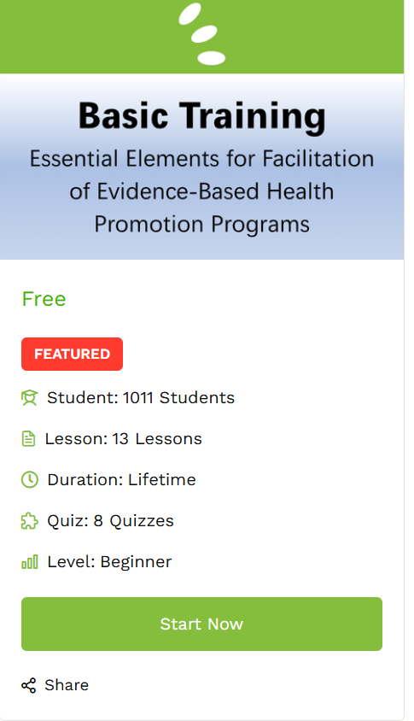
- When you’re ready to begin, click the “Start Now” button on the right side:

- If this is your first time logging in to our training platform, you’ll need to sign up
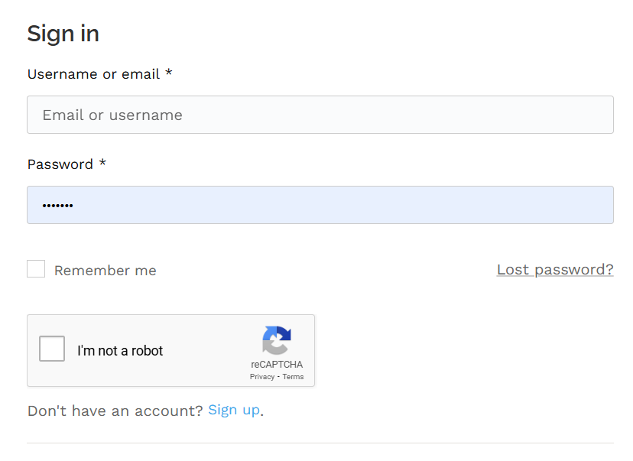
  - If you have logged in previously, you may simply enter your username or email and password and login.
- To sign up, enter your information, click the “I’m not a robot button” and be sure to click “Place Order” at the bottom of the screen.
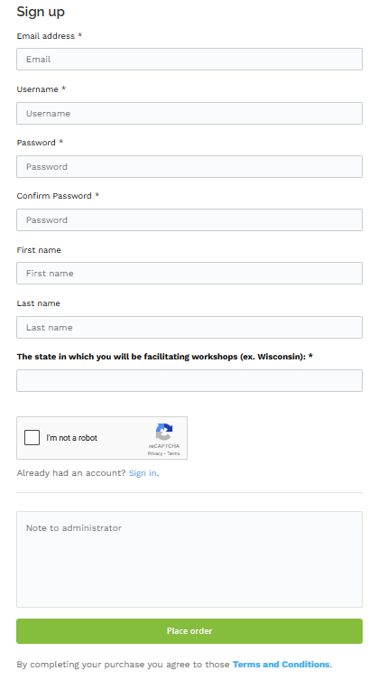
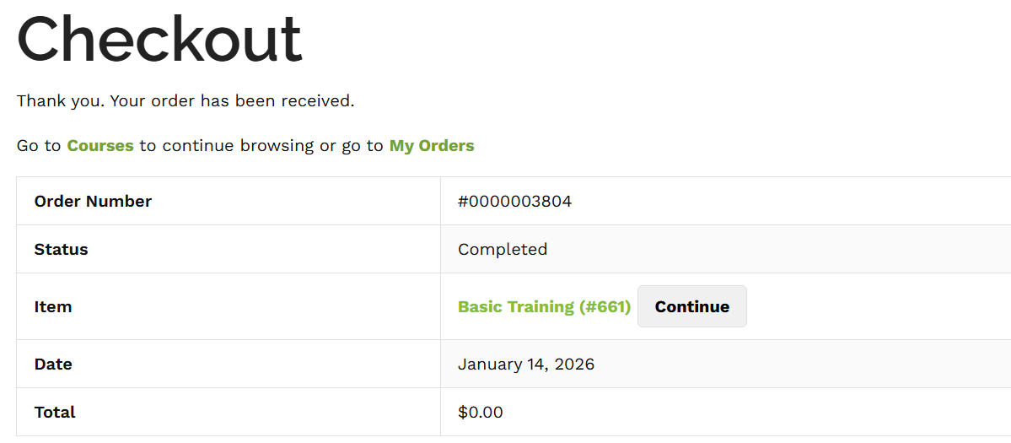
- You will then be shown the checkout page and thanked for your order:
  - From there, you can click on the continue button next to “Basic Training” to get started.

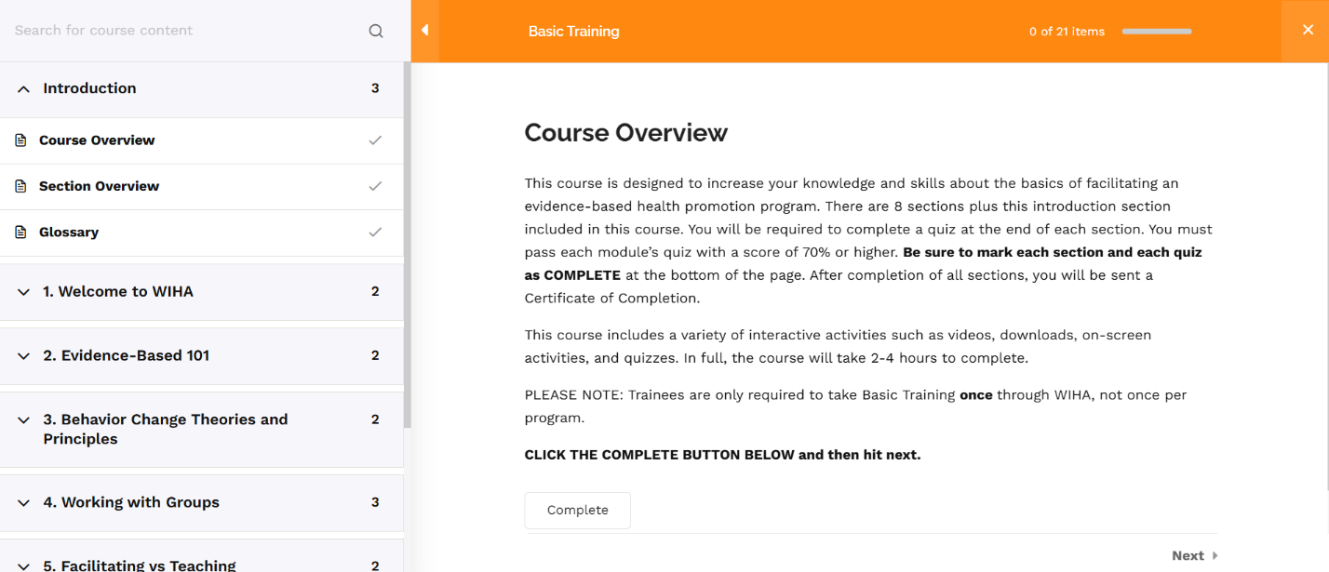
- You will then arrive at the course page.

- To complete the course – you’ll need to work through each of the sections on the left side of the screen. Please be sure to click on each one that has a dropdown error and complete the different lessons within each. For example, the Introduction section is expanded in the example above and has three lessons: Course Overview, Section Overview, and Glossary. Each of those lessons needs to be reviewed. After reviewing, you must hit the Complete button at the bottom of the page on each lesson and quiz.

- In Basic Training, each lesson has a quiz. Once you have completed the course in full (i.e. marked complete on every lesson), and passed every quiz with a score of 70% or higher, then you will see the “Finish Course” button on the lower right side of Module 8’s last lesson:
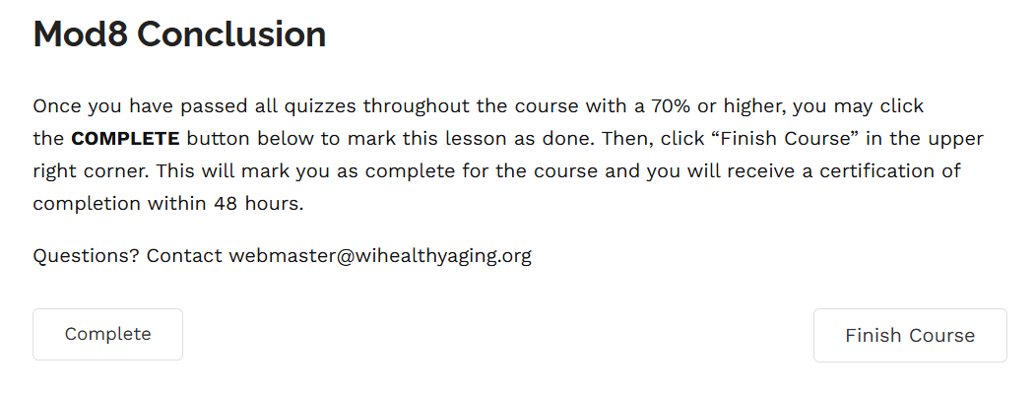
  - NOTE: If you do NOT see the “Finish Course” button, then you either have not pressed the “Complete” button for each lesson, or you have not passed all quizzes with a score of 70% or higher. If you go back to the course page (https://training.wihealthyaging.org/courses/basic-training-wiha/) and you look at the curriculum and “Expand All Sections”, you’ll be able to see if a green check is missing from any of the boxes.

If you need help, please reach out to webmaster@wihealthyaging.org

